## TrueChian Development Practice : Debugging with IDE

##### Experiment Environment:

* macOS 10.13.6
* go version go1.9.3 darwin/amd6
* goland 2018.2.1
* truechain-fpow branch

### Clone the repository From Github:

git clone -b fpow ow https://github.com/truechain/truechain-engineering-code.git

### Download GoLand Development IDE:

https://www.jetbrains.com/go/download

PS: Please downloading the version which matches to your OS.you can get the 30-days trial or buy it.

### GoLand Configuration:

Environment Variable Configuration: GOROOT

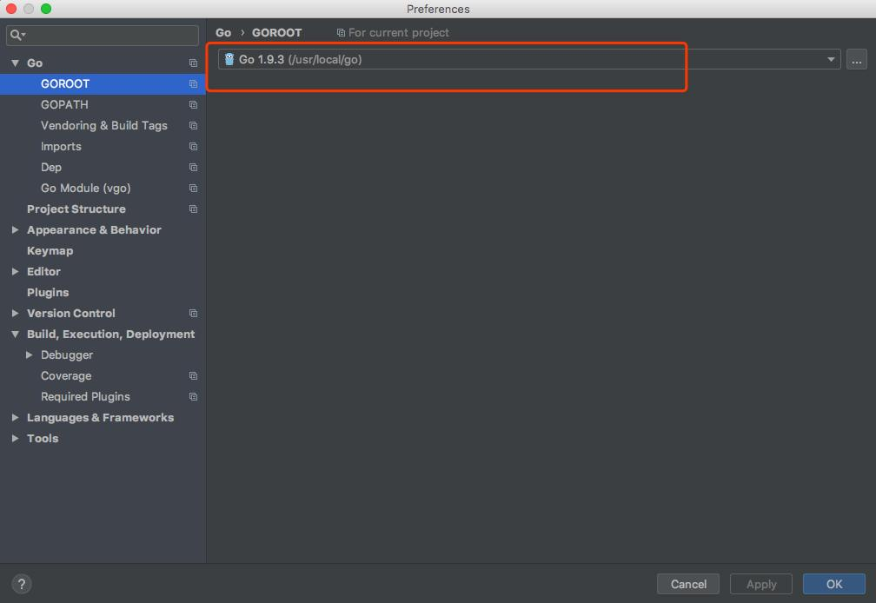

Environment Variable Configuration: GOPATH

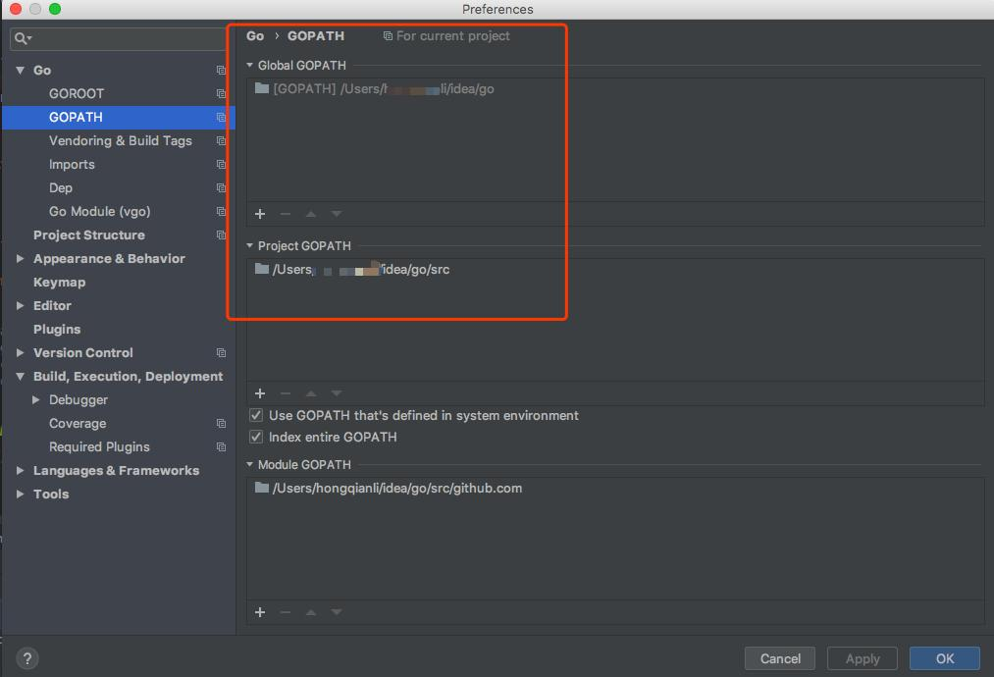

### Import Code:

File >> Open ${ProjectPath}

### Compile:

$ make getrue

PS: After “make” , the executable file of “geture” will generate at the path of “build/bin”

$ ./build/bin/getrue --datadir ./data --networkid 1004 --testnet --etherbase 0x8a45d70f096d3581866ed27a5017a4eeec0db2a1 console --singlenode --bftkeyhex "c1581e25937d9ab91421a3e1a2667c85b0397c75a195e643109938e987acecfc"

PS: start up a Committee Node to mine. more info about arguments are listed below:

--datadir ./data => the path of our data to save

--networkid 1004 => network id. only the machines with the same network id can connected to each other

--singlenode => this node is a single node

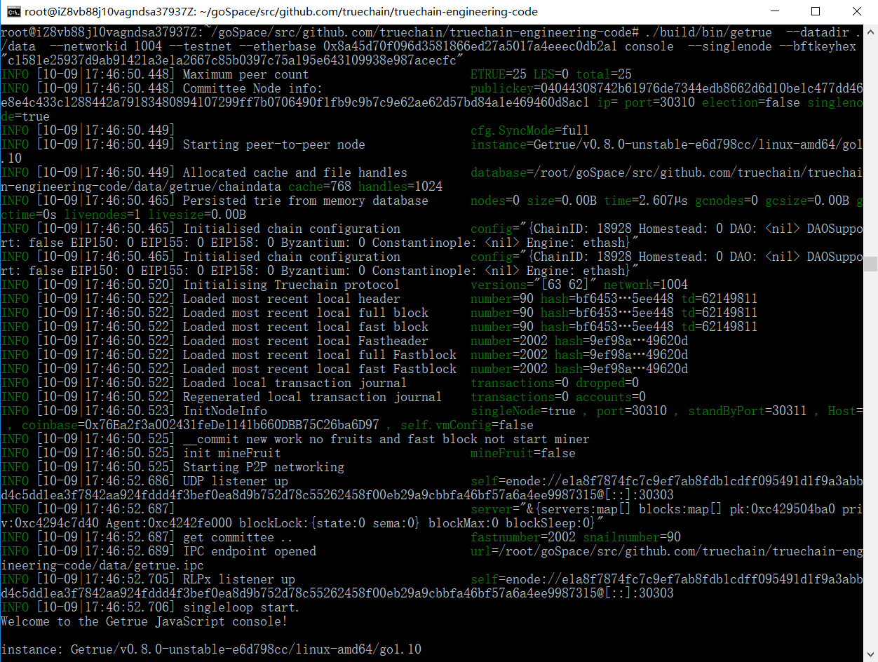

$./build/bin/getrue --datadir ./data --networkid 1004 --testnet --etherbase 0x8a45d70f096d3581866ed27a5017a4eeec0db2a1 console --mine

PS: Start up a Snail Block Node to mine. The “block” and “fruit” are mined at the same.

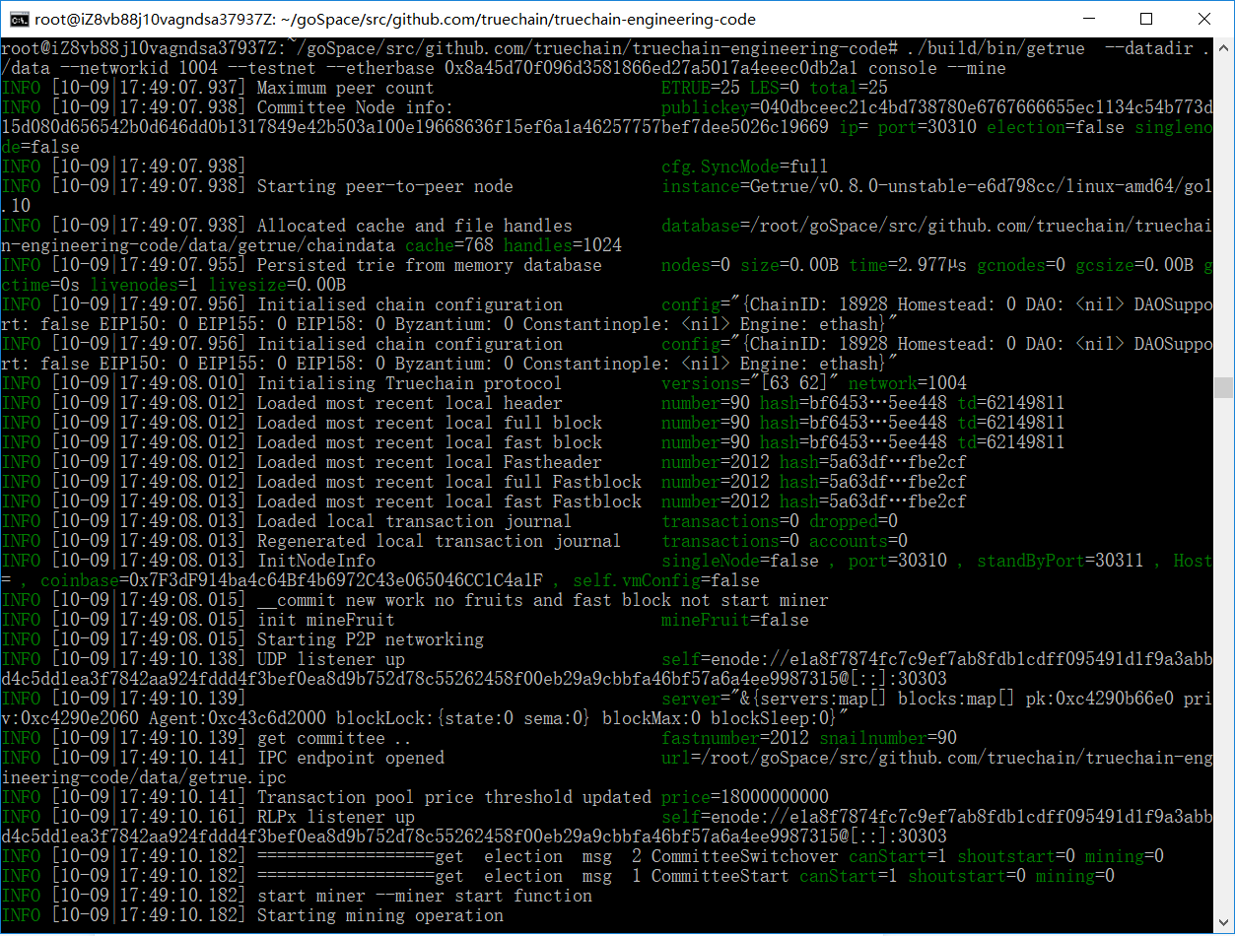

$ ./build/bin/getrue --datadir ./data --networkid 1004 --testnet --etherbase 0x8a45d70f096d3581866ed27a5017a4eeec0db2a1 console --mine --minefruit

PS: Start up a Snail Block Node to mine. The argument of “--minefruit” means only mining “fruit”.

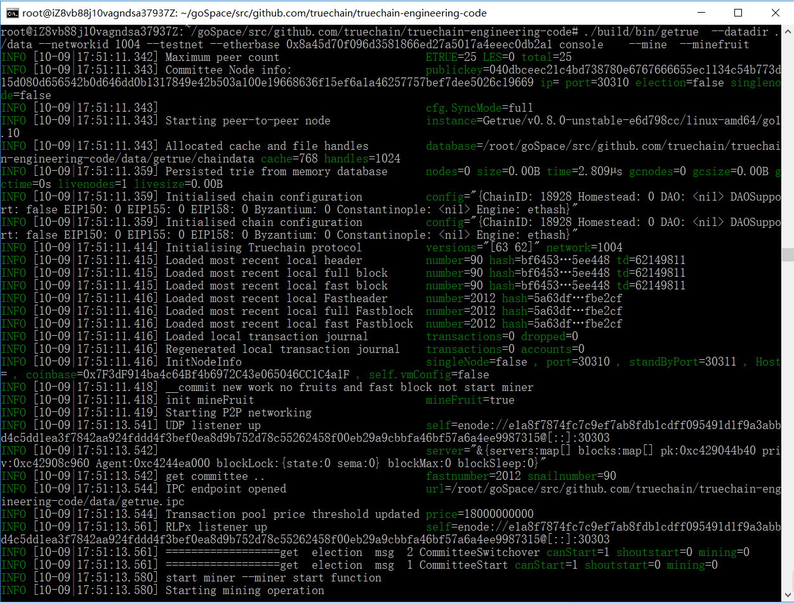

### Debug Mining Code

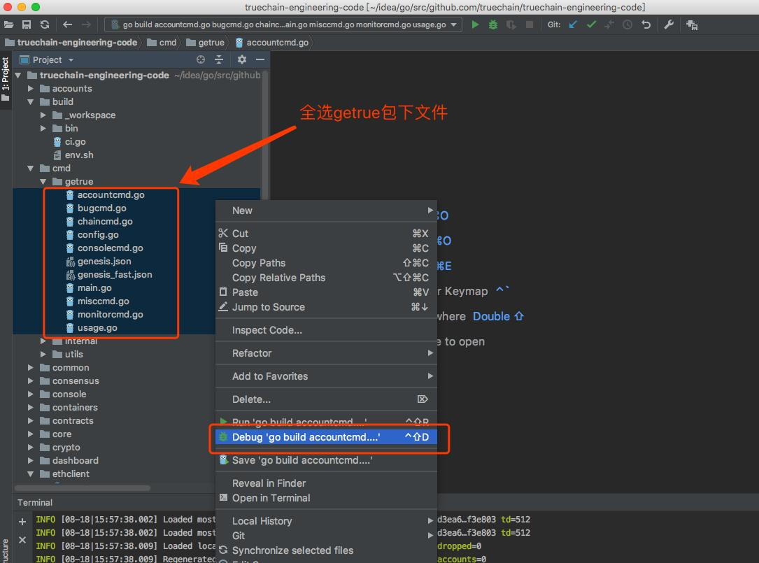

PS: select all the files in getrue folder

### add a breakpoint in any line of the code, start debugging .

